**SECTION 4**

# USE CASE DIAGRAM

A use case diagram is a graphical depiction of a user's possible interactions with a system. A use case diagram referred as a Behavior model or diagram. It simply describes and displays the relation or interaction between the users or customers and providers of application service or the system. It describes different actions that a system performs in collaboration to achieve something with one or more users of the system.

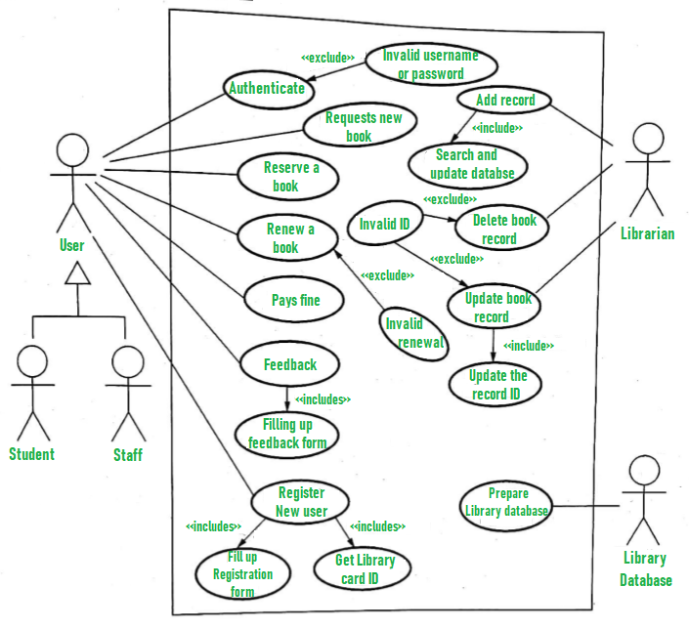

1. User who registers himself as a new user initially is regarded as staff or student for the library system.

* For the user to get registered as a new user, registration forms are available that is needed to be fulfilled by the user.
* After registration, a library card is issued to the user by the librarian. On the library card, an ID is assigned to cardholder or user.

1. After getting the library card, a new book is requested by the user as per there requirement.
2. After, requesting, the desired book or the requested book is reserved by the user that means no other user can request for that book.
3. Now, the user can renew a book that means the user can get a new due date for the desired book if the user has renewed them.
4. If the user somehow forgets to return the book before the due date, then the user pays fine. Or if the user forgets to renew the book till the due date, then the book will be overdue and the user pays fine.
5. User can fill the feedback form available if they want to.
6. Librarian has a key role in this system. Librarian adds the records in the library database about each student or user every time issuing the book or returning the book, or paying fine.
7. Librarian also deletes the record of a particular student if the student leaves the college or passed out from the college. If the book no longer exists in the library, then the record of the particular book is also deleted.